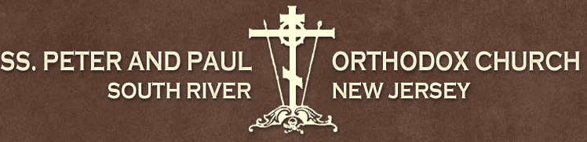

Dear Parishioners and Friends,

The SS Peter and Paul “FALL Ethnic Festival” is rapidly upon us. The Festival will be held in the church hall on Saturday October 17, 2015, from 10 am to 4 pm.

The festival will feature lots of food (such as stuffed cabbage, pierogies, kielbasa and sauerkraut etc.) a Russian Tea room (ethnic baked goods), handmade craft items, entertainment and a Tricky Tray.

Orders are being taken for babkas. Please contact Jim and Debbie Jones for babkas at 732-238-0735.

So please mark your calendars and join us with family and friends on Saturday. October 17, 2015. It promises to be a fun-packed day for the entire family.

Respectively, your Festival Committee,
Greg Messeka
Sandy Saurman
Pete and Debbie Silowka

